


MyWorkSpace 2.2
Administration Manual

Research & Development Unit
Open Source Competency Centre (OSCC),
MAMPU,
Lot E30234, Enterprise Building 3,
63000 Cyberjaya, Selangor
Tel: 038319 1200
Fax: 0383193206
http://opensource.mampu.gov.my

Table of Contents
Introduction 1
MyWorkSpace Architecture 2
Hardware and Software Requirement 3
Prerequisites 4
CentOS 5 4
Apache 6
Postfix 6
DBMail 6
MySQL 8
Administration Guide 9
User Management 55
Add User 56
Modify User 56
Delete User: 56
Maintenance 57

Introduction
MyWorkSpace is a collaboration suite which provide calendar, address book, notes and task todo. MyWorkSpace consists of this following components:
- Web User Interface
- Mail Server component
- Virus Scanning component
- SPAM Filtering component
- Users Administration component

Features:
- Public and shared resources
- Integrated user management, group support and permission system with the tools from third party
- Synchronization with PDAs, mobile phones and groupware client
- Message filtering and searching
- Spell checking
- Quota support

MyWorkSpace Architecture

- Outlook
- Thunderbird
Clients
Web Browser
Clients

- IMP (Web Mail)
- Kronolith (Calendar)
- Nag (Tasks)
- Turba (Contacts)
- Ingo (Filters)

Collaboration Suite

SMTP
IMAP

SMTP

IMAP

- Postfix
- DBMail
Email System
- Spam Filtering
- Virus Scanning
MySpamGuard
Database
MySql
Data

Hardware and Software Requirement
Hardware
- Pentium IV and above
- 512MB RAM and above
- 10GB HD and above

Software
- CentOS 5 / Red Hat Enterprise Linux – Operating System
- Apache – Web Server
- Postfix – Mail Transport Agent (MTA)
- MySql – Database
- DBMail – open source IMAP server-side email solution
- MySpamGuard – Email Spam Filtering and Virus Scanning

Prerequisites

CentOS 5
CentOS is an Enterprise-class Linux Distribution derived from sources freely provided to the public by a prominent North American Enterprise Linux vendor. CentOS is perfect for servers and cluster nodes where newer software is not a requirement.
CentOS preferred software updating tool is based on yum, although support for use of an up-to-date variant exist. Each may be used to download and install both additional packages and their dependencies, and also to obtain and apply periodic and special (security) updates from repositories on the CentOS Mirror Network. The current version of CentOS is CentOS 5.0 and it was released on April 12 2007.

How to install CentOS 5.

- Place the DVD/CD-ROM in your DVD/CD-ROM drive and boot your system from the DVD/CD-ROM. If the DVD/CD-ROM drive is found and the driver loaded, the installer will present you with the option to perform a media check on the DVD/CD-ROM. This will take some time, and you may option to skip over this step.
- The welcome screen will appear and click 'Next' to proceed.
- Language selection - Select the language and it will become the default language for the operating system once it is installed. Selecting the appropriate language also helps target your timezone configuration later in the installation. The installation program tries to define the appropriate time zone based on what you specify on this screen. Once you select the appropriate language, click 'Next' to continue.
- Keyboard Layout Selection - Select the correct layout type for the keyboard you would prefer to use for the installation and as the system default. Click 'Next' to continue installation.
- Setup your disk partitioning, the first three option will perform automatic partitioning while 'Create customs layout' will perform manual partition.
- For Network configuration, the installation program will automatically detects any network devices and its hostname. You can edit its configuration or just click 'Next' to continue.
- Set your time zone by selecting the city closest to your computer's physical location. Select 'System Clock uses UTC' if your system is set to UTC. (for this installation, unselect it)
- Set root password. This is the most important steps because root account is used for system administration.
- You can customize software selection of your system or do it after installation.
- A screen preparing the installation will be appear. For your reference, a complete log of your installation can be found in /root/install.log once you reboot your system.
- This step is when the installation program installing all the packages. How quickly this happens depends on the number of packages you have selected and your computer's speed.
- Now your installation is complete. The installation program prompts you to prepare your system for reboot.
- Then, start your CentOS 5 in run level 5 (graphical run level), the Setup Agent is presented, which guides you through the CentOS configuration. Using this tool, you can set up your system time and date, install software, register your machine with CentOS Network and more.

Taken from: http://www.centos.org/docs/5/html/Installation_Guide-en-US/
Reference: http://www.howtoforge.com/perfect_server_centos4.5

Apache
The Apache HTTP Server Project is an effort to develop and maintain an open-source HTTP server for modern operating systems including UNIX and Windows NT. The goal of this project is to provide a secure, efficient and extensible server that provides HTTP services in sync with the current HTTP standards.

Postfix
Postfix is a free software/open source mail transfer agent (MTA), a computer program for the routing and delivery of email. It is intended as a fast, easy to administer and secure alternative to the widely-used Sendmail MTA. The strengths of Postfix are its resilience against buffer overflows and also its handling of large amounts of e-mail.
Website: http://www.postfix.org

DBMail
DBMail is the name of a group of programs that enables the possibility of storing and retrieving mail messages form a database. In our application, we are using MySQL as database backends. DBMail is made up of several components. A normal MTA (Postfix) is used for accepting messages. Postfix hands the messages over to dbmail-smtp, using a pipe interfac, or dbmail-lmtpd, using LMTP (Local Mail Transport Protocol). These programs take care of delivering the message into the database. Messages can be retrieved from database using dbmail-pop3d (POP3 protocol) and dbmail-imapd (IMAP4Rev1 protocol).
The whole email is stored in the database, that includes attachments. The DBMail programs do not have to touch the filesystem to retrieve or insert emails. User information is also stored in the database, so users do not need an account on the machines DBMail is running on.

The advantages of DBMail:
- Scalability
Dbmail is as scalable as the database system that is used for the mail storage. In theory millions of accounts can be managed using dbmail. One could, for example, run 4 different servers with the pop3 daemon each connecting to the same database (cluster) server.
- Manageability
Dbmail is based upon a database. Dbmail can be managed by changing settings in the database (f.e. using PHP/Perl/SQL), without needing shell access.
- Speed
Dbmail uses very efficient, database specific queries for retrieving mail information. This is much faster then parsing a filesystem.
- Security
Dbmail has got nothing to do with the filesystem or interaction with other programs in the Unix environment which need special permissions. Dbmail is as secure as the database it's based upon.
- Flexibility
- Changes on a Dbmail system (adding of users, changing passwords etc.) are effective immediately. Users can be stored in the database, or managed separately in an LDAP server such as OpenLDAP or Active Directory.

Website: http://www.dbmail.org/index.php?page=overview

MySQL
The MySQL database has become the world's most popular open source database because of its consistent fast performance, high reliability and ease of use.

Administration Guide
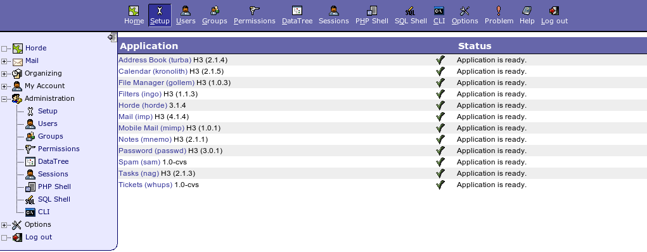
Administration Setup Page
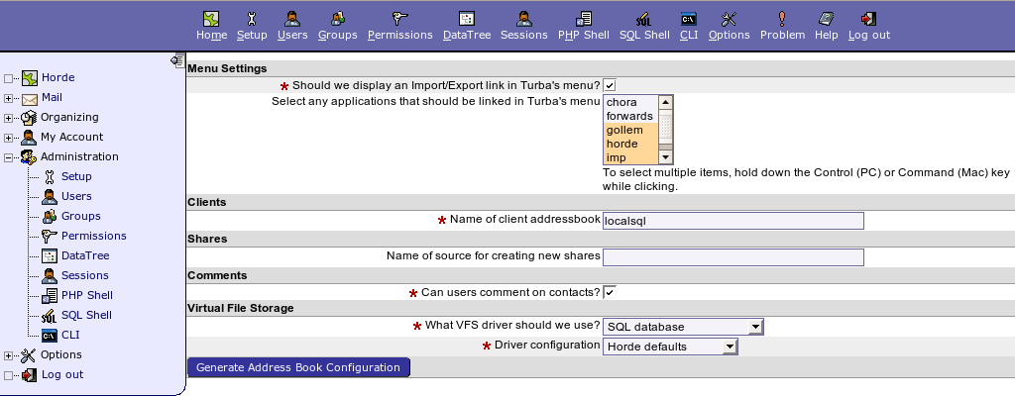
Address Book Configuration

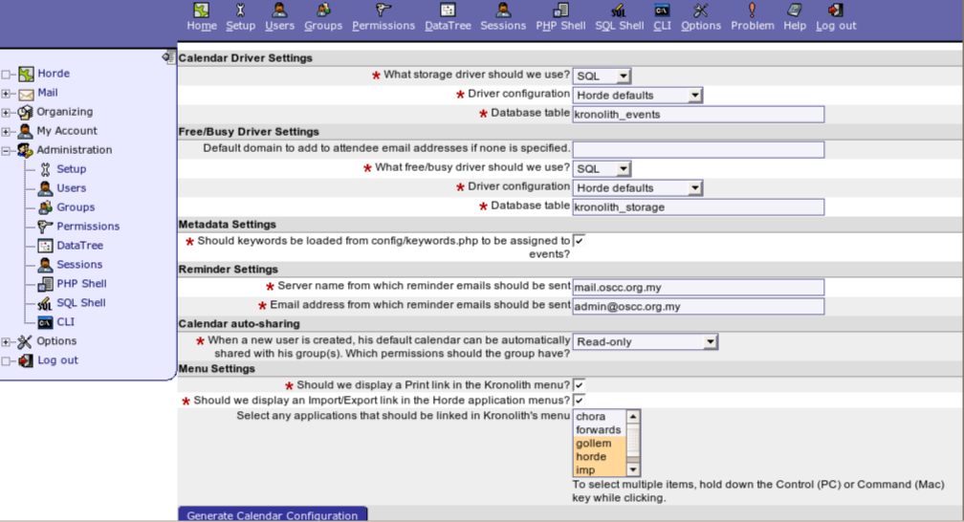
Calendar Configuration

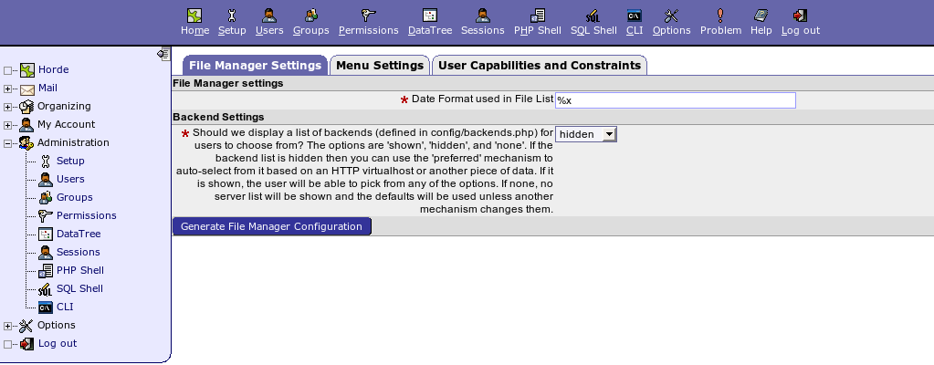
File Manager Configuration – File Manager Settings

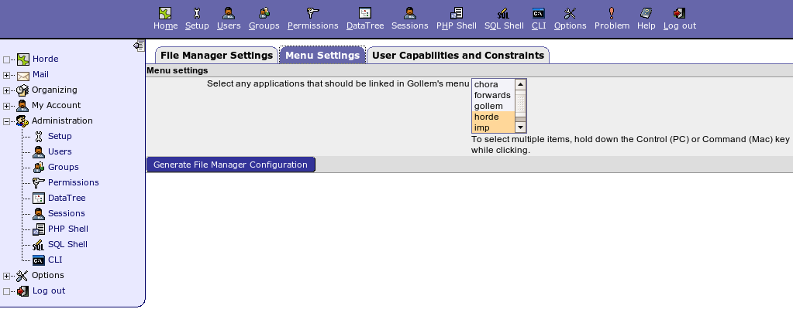
File manager – Menu Settings

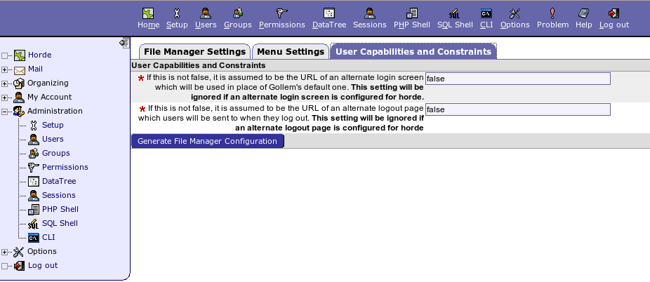
File Manager – User Capabilities and Constraints

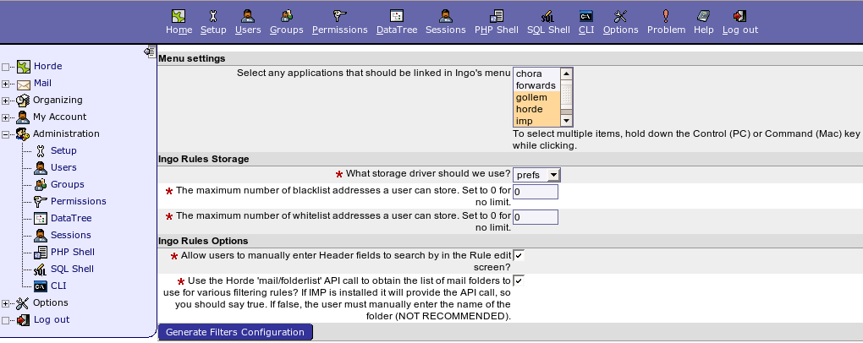
Filters Configuration

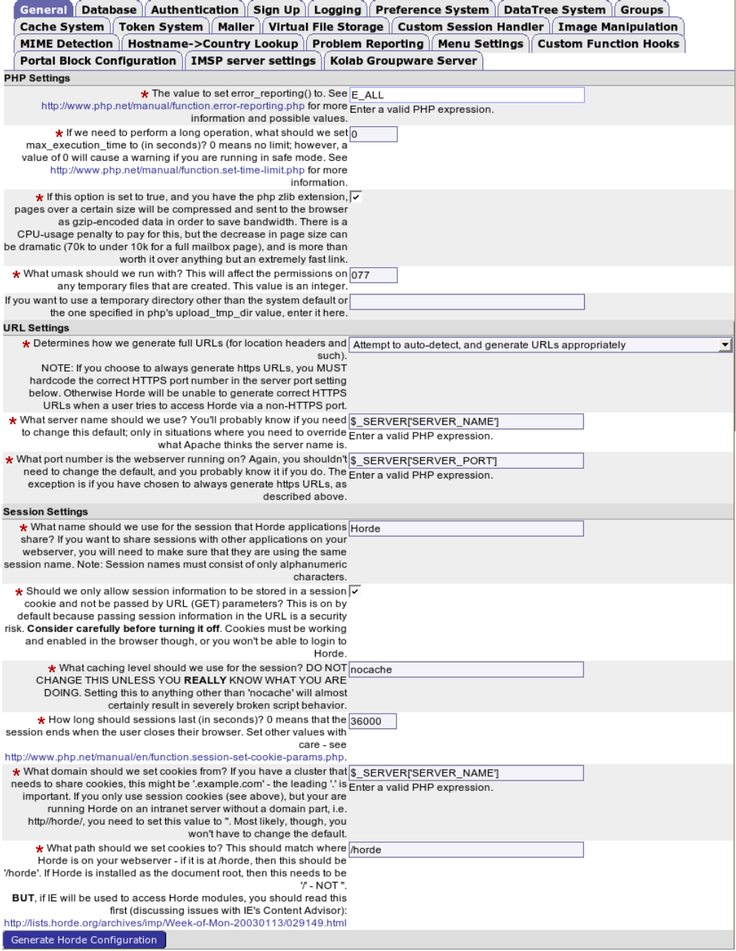
Horde Cofiguration – General

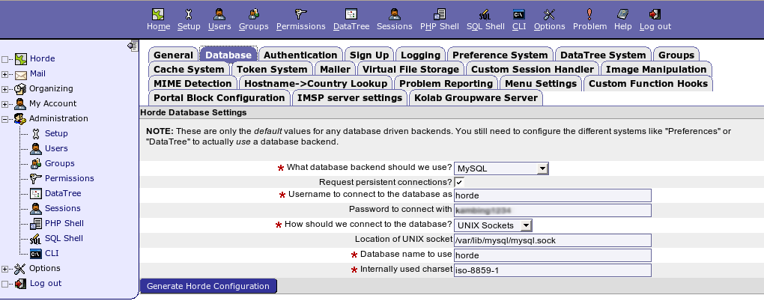
Horde Configuration – Database

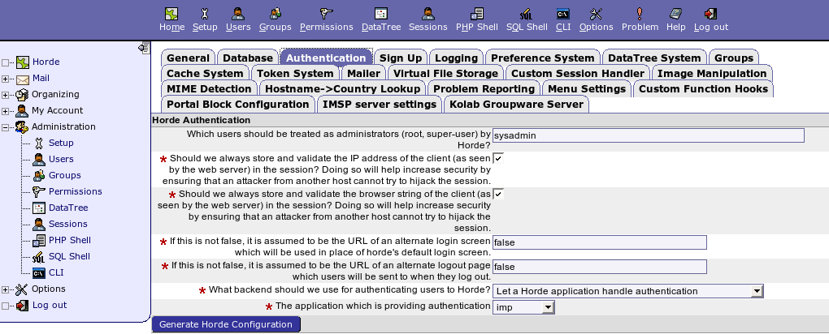
Horde Configuration – Database

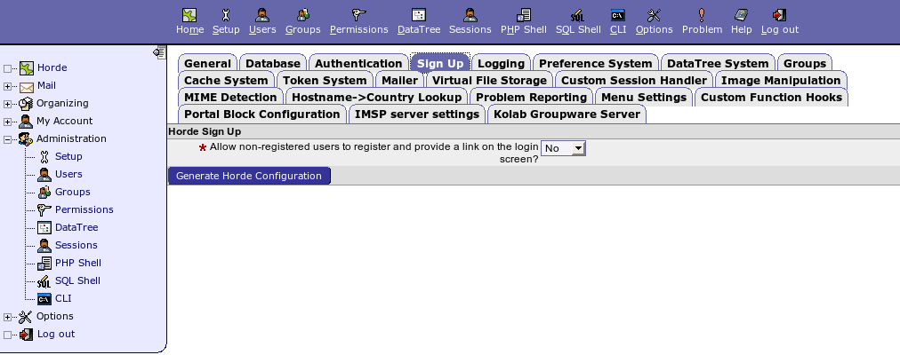
Horde Configuration – Sign Up

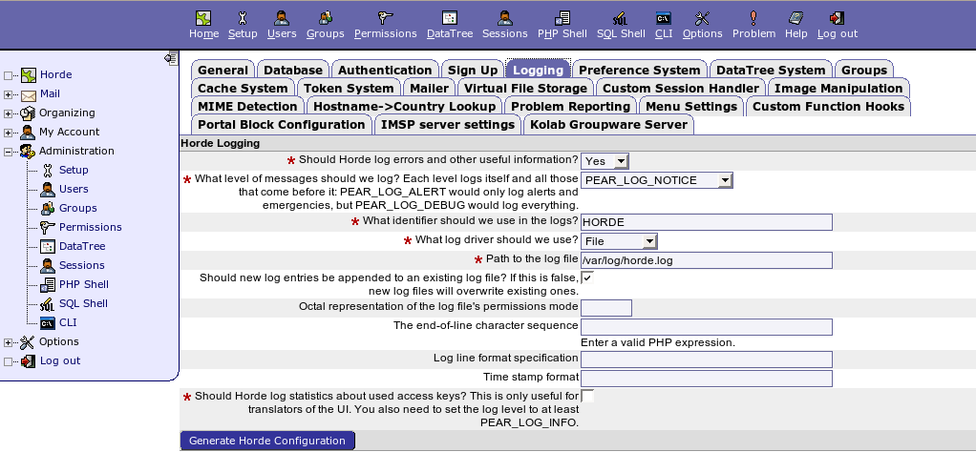
Horde Configuration – Logging

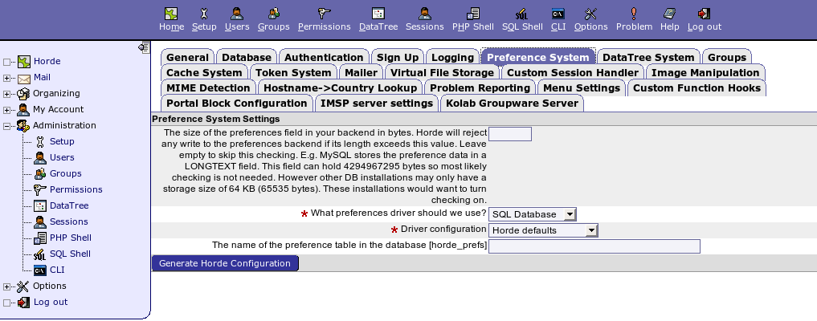
Horde Configuration – Preferences System

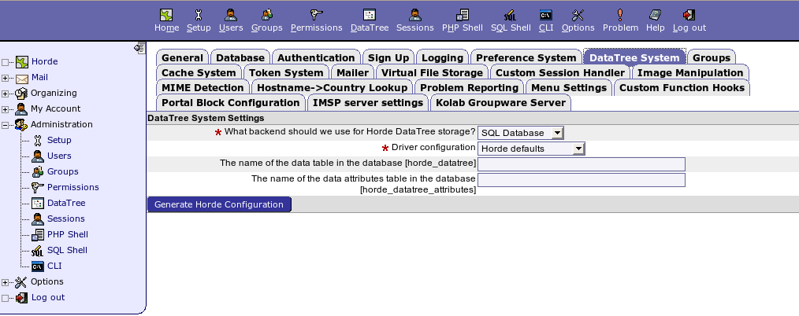
Horde Configuration – DataTree System

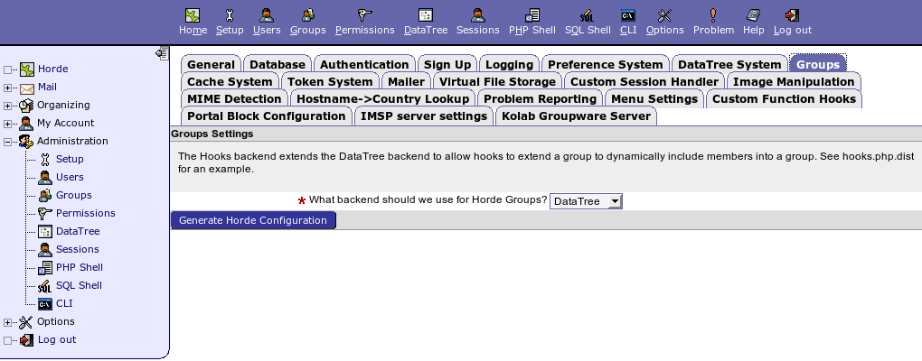
Horde Configuration – Group

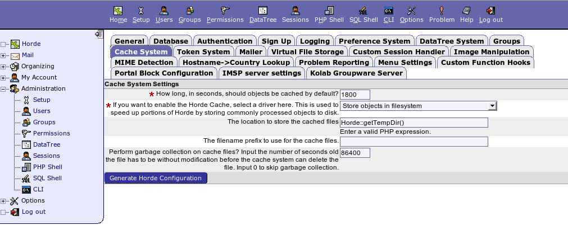
Horde Configuration – Cadche System

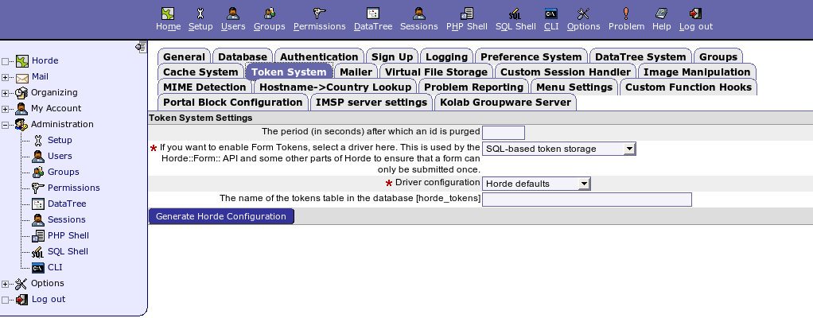
Horde Configuration – Token System

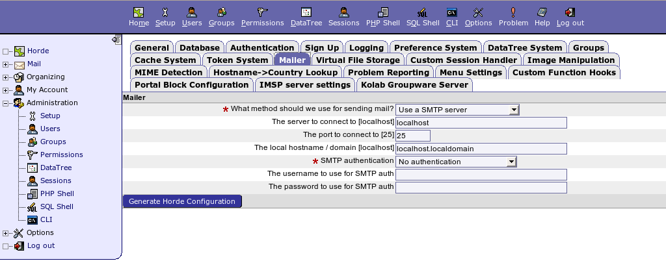
Horde Configuration – Mailer

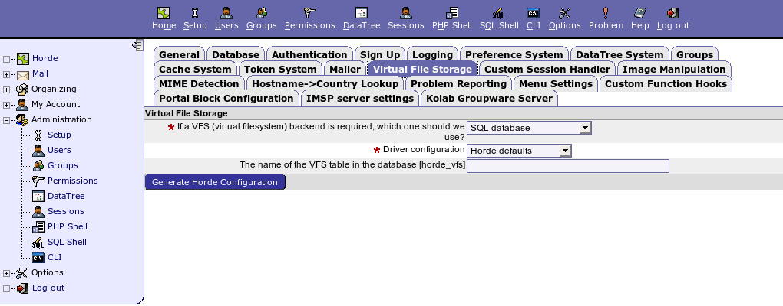
Horde Configuration – Virtual File Storage

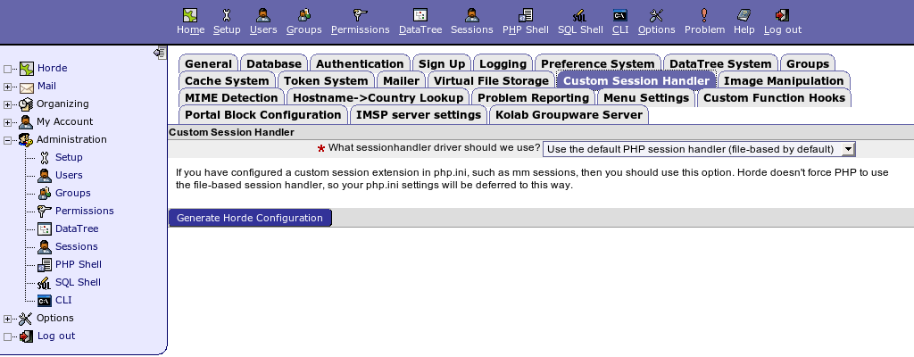
Horde Configuratio – Custom Session Handler

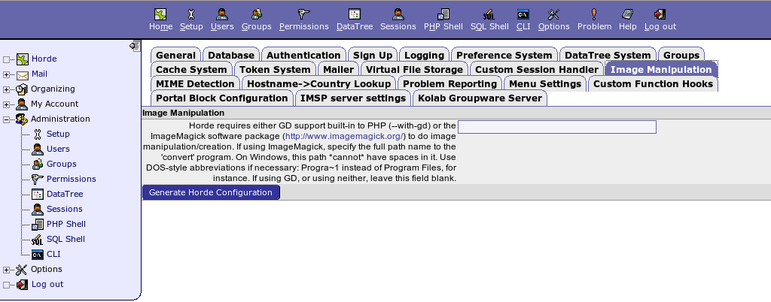
Horde Configuration – Image Manipulation

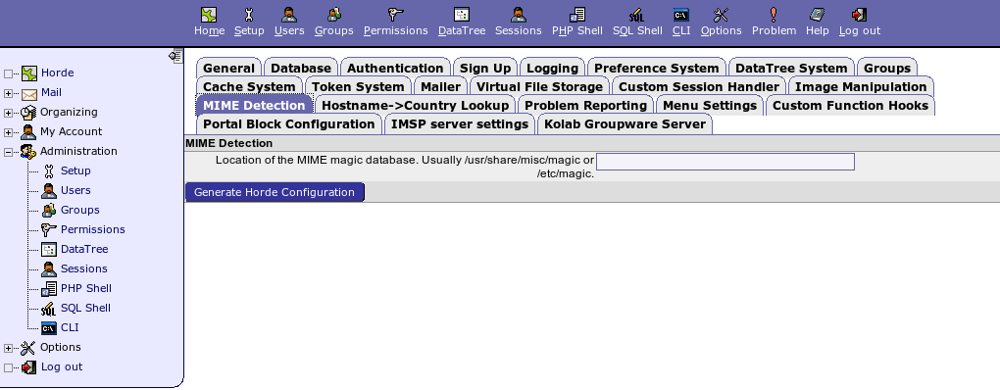
Horde Configuration – MIME Detection

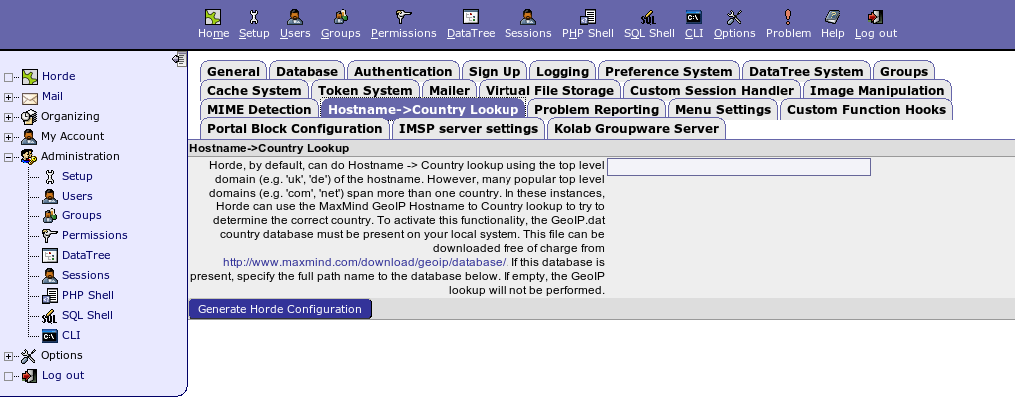
Horde Configuration – Hostname->Country Lookup

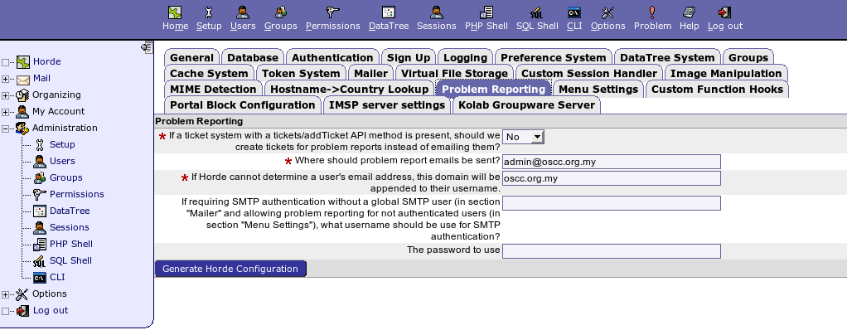
Horde Configuration – Problem Reporting

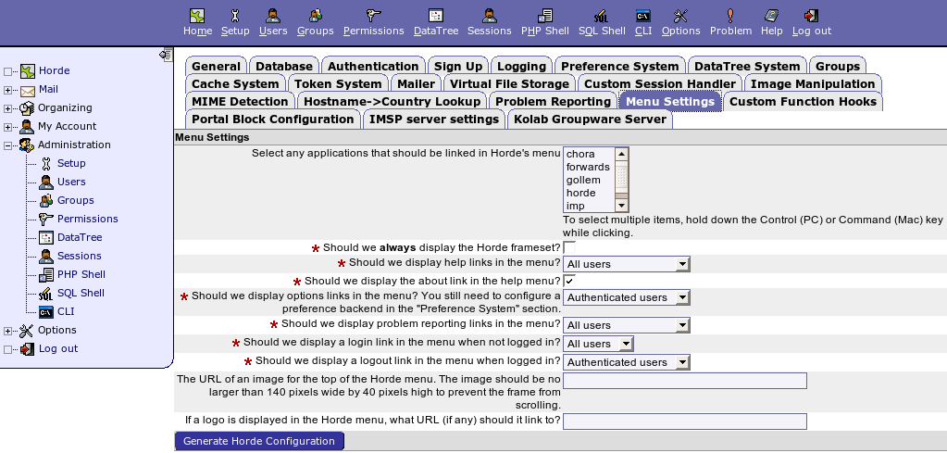
Horde Configuration – Menu Settings

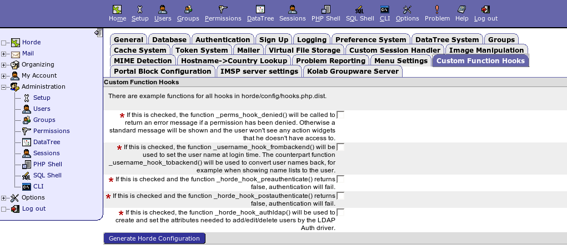
Horde Configuration – Customs Function Hooks

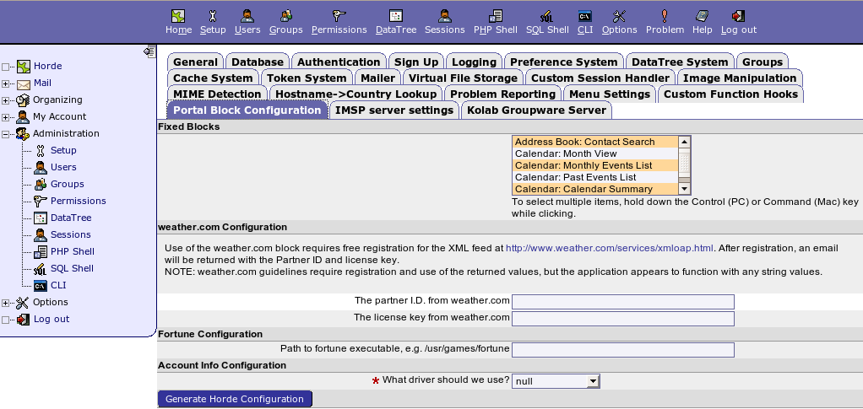
Horde Configuration – Portal Block Configuration

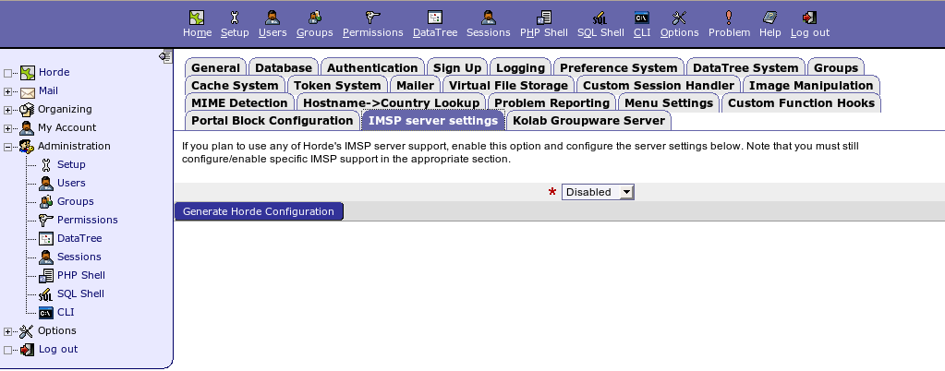
Horde Configuration – IMSP server settings

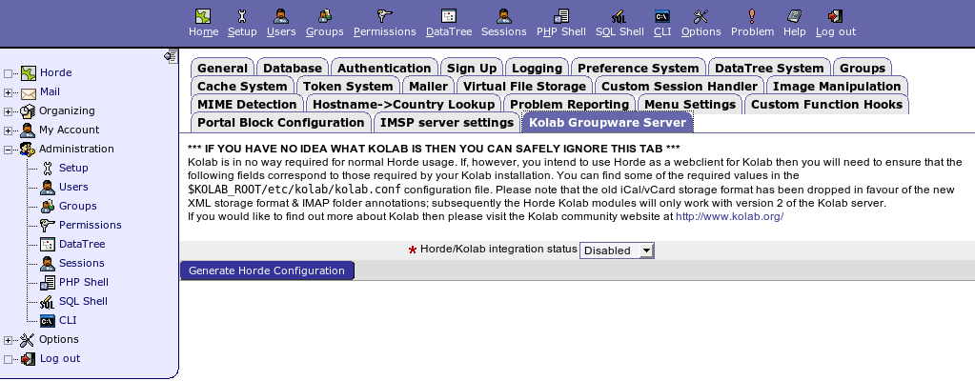
Horde Configuration – Kolab Groupware Server

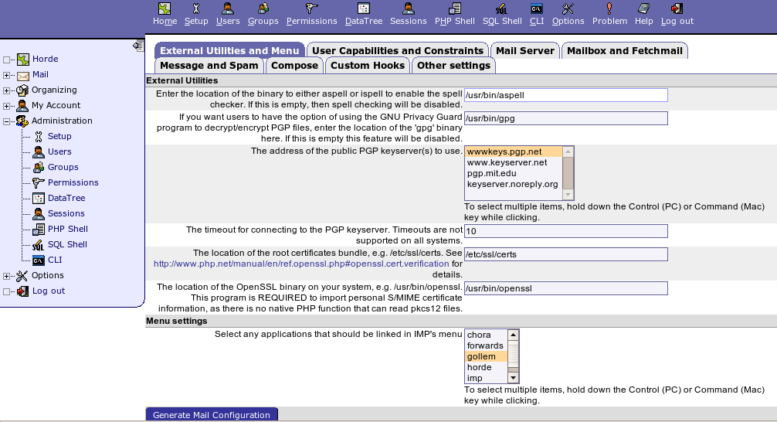
Mail Configuration – External Utilities and Menu

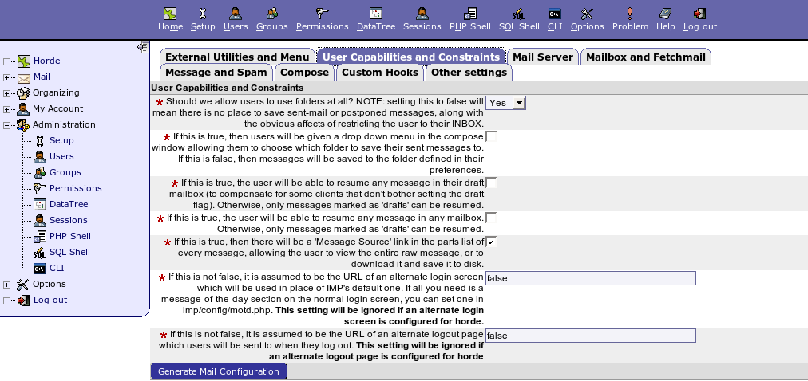
Mail Configuration – User Capabilities and Constraints

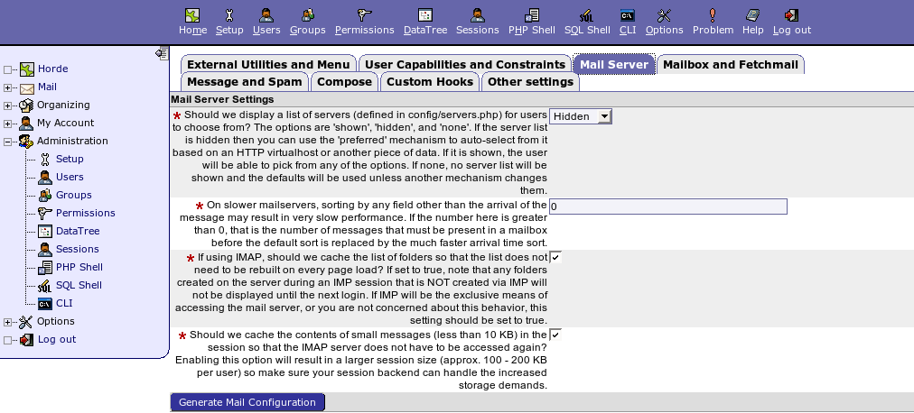
Mail Configuration – Mail Server

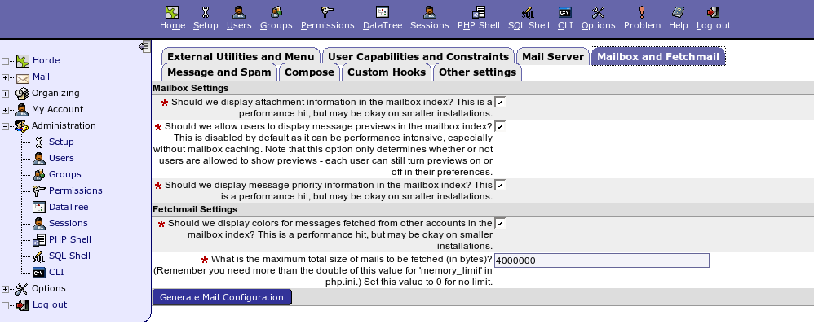
Mail Configuration – Mailbox and Fetchmail

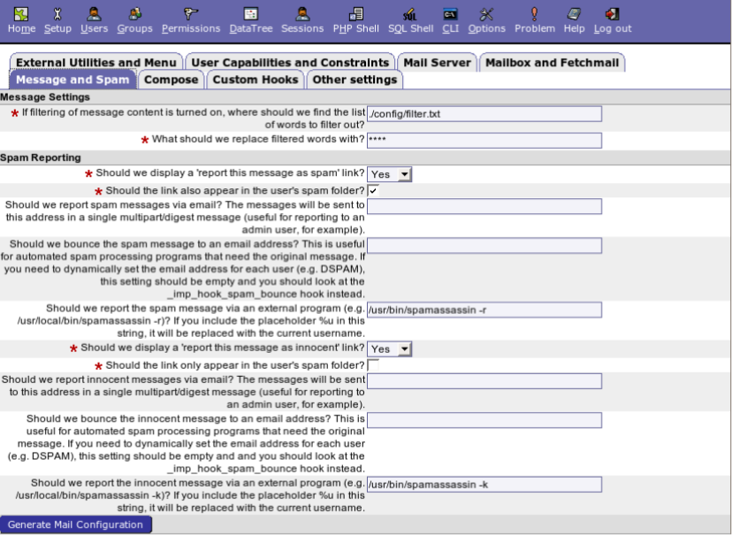

Mail Configuration – Message and Spam

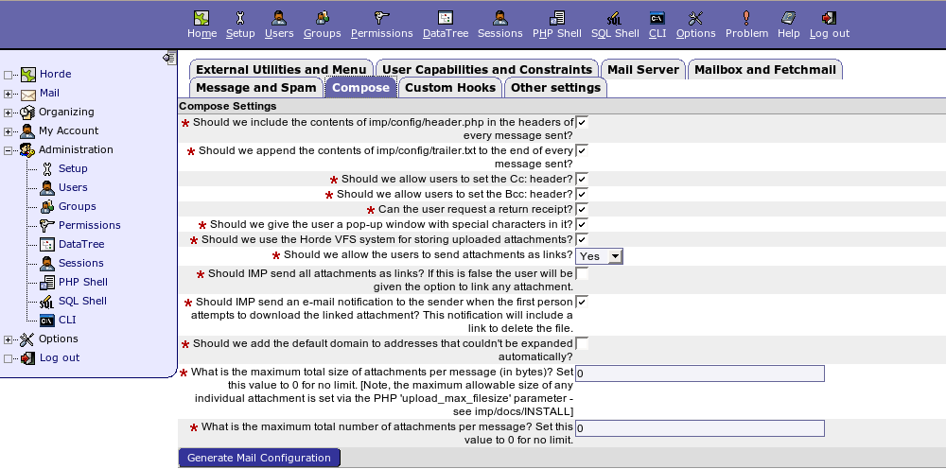
Mail Configuration - Compose

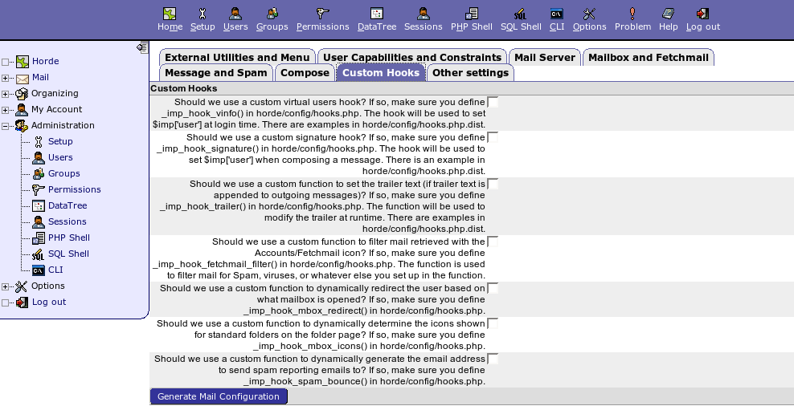
Mail Configuration – Custom Hooks

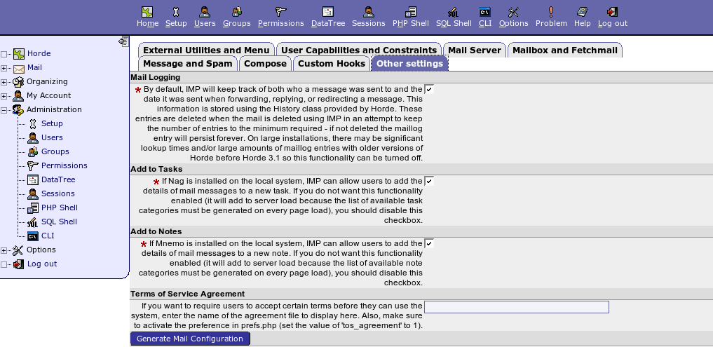
Mail Configuration – Other settings

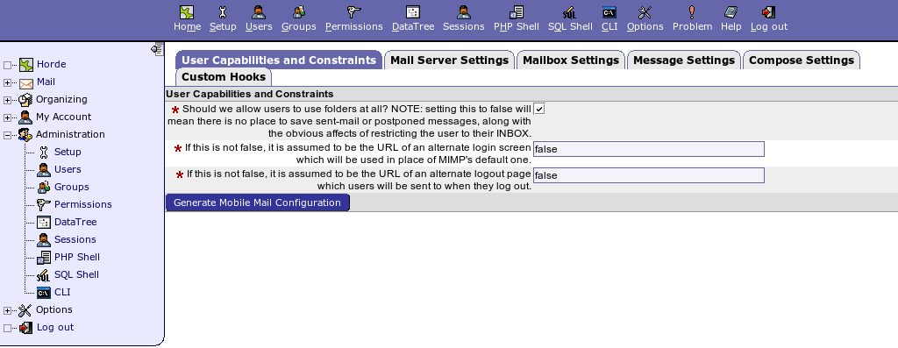
Mobile Mail Configuration – User Capabilities and Constraints

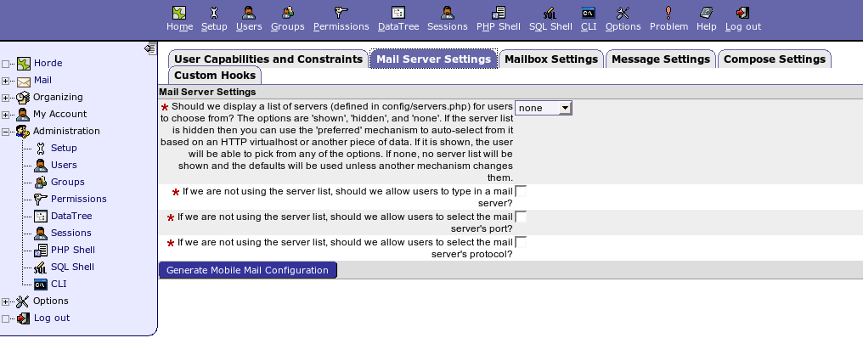
Mobile Mail configuration – Mail Server Settings

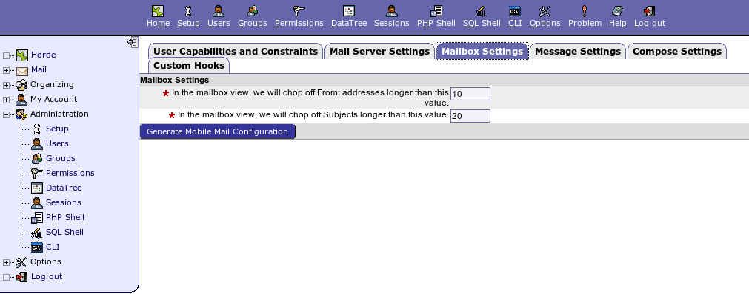
Mobile Mail Configuration – Mailbox Settings

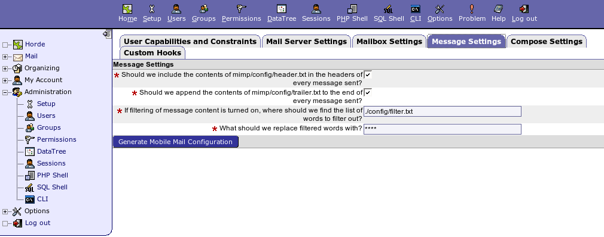
Mobile Mail Configuration – Message Settings

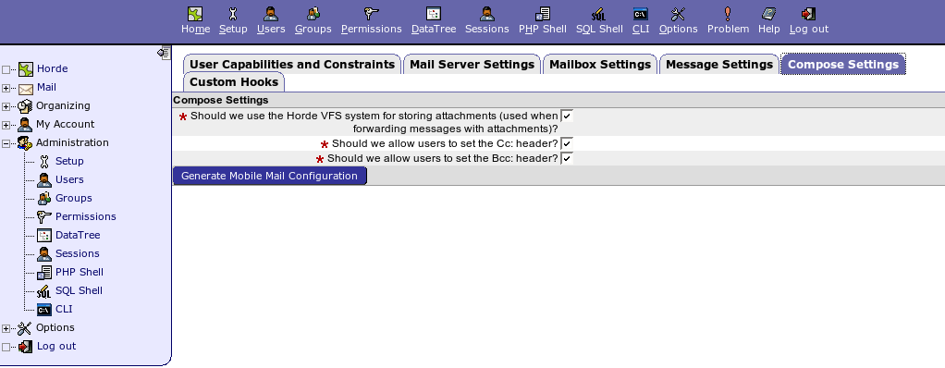
Mobile Mail Configuration – Compose Settings

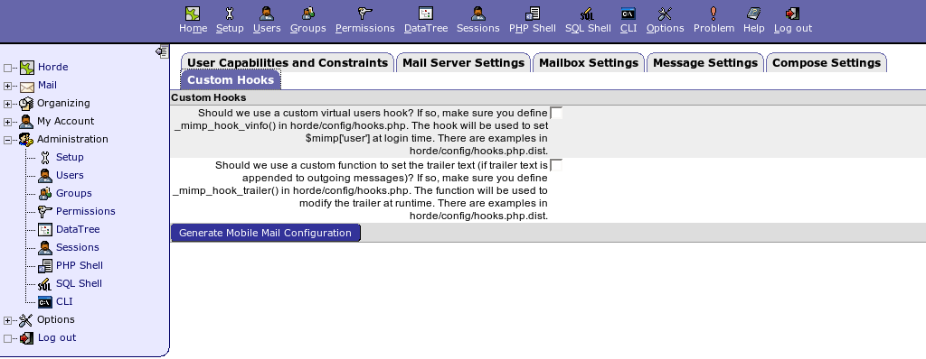

Mobile Mail Configuration – Custom Hooks

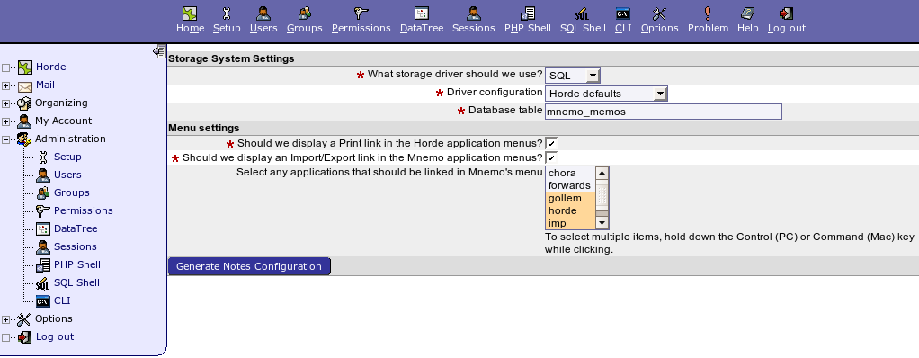
Notes Configuration

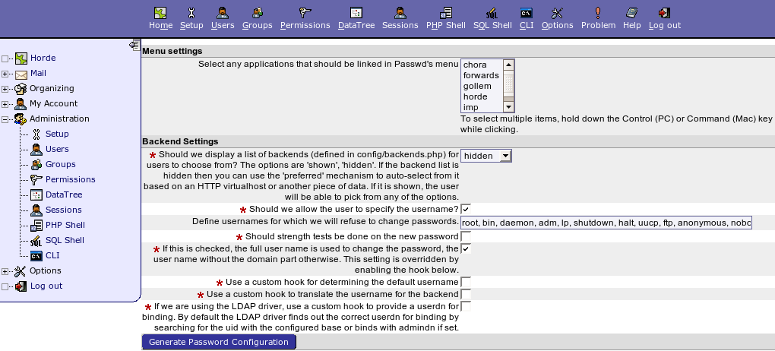
Password Configuration

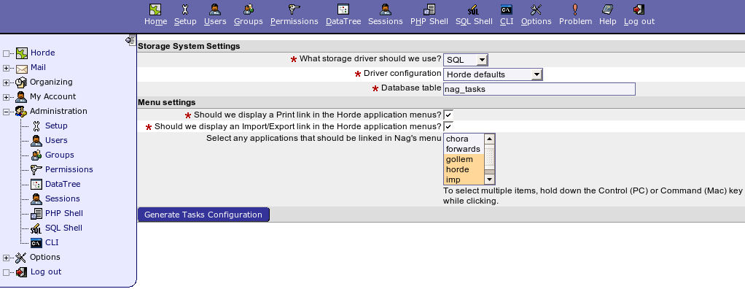
Tasks Configuration

User Management
[root@localhost]# dbmail-users
Use this program to manage your DBMail users.
See the man page for more info. Modes of operation:

-a user add a user
-d user delete a user
-c user change details for a user
-e user empty all mailboxes for a user
-l uspec list information for matching users
-x alias create an external forwarding address

Summary of options for all modes:
-w passwd specify user's password on the command line
-W [file] read from a file or prompt for a user's password
-p pwtype password type may be one of the following:
plaintext, crypt, md5-hash, md5-digest, md5-base64
each type may be given a '-raw' suffix to indicate
that the password argument has already been encoded.
-P [file] pull encrypted password from the shadow file
-u user new username (only useful for -c, change)
-g client assign the user to a client
-m max set the maximum mail quota in <bytes>B,
<kbytes>K, or <mbytes>M, default in bytes
specify 0 to remove any mail quota limits
-s alia.. adds a list of recipient aliases
-S alia.. removes a list of recipient aliases (wildcards supported)
-t fwds.. adds a list of deliver-to forwards
-T fwds.. removes a list of deliver-to forwards (wildcards supported)

Common options for all DBMail utilities:
-f file specify an alternative config file
-q quietly skip interactive prompts
use twice to suppress error messages
-n show the intended action but do not perform it, no to all
-y perform all proposed actions, as though yes to all
-v verbose details
-V show the version
-h show this help message

Add User
[root@localhost]# dbmail-users -v -a <username> -w <password> -p md5-base64 -s <domain>

example:
[root@localhost]# dbmail-users -v -a ahmad -w ahmad123 -p md5-base64 -s example.gov.my

Modify User
[root@localhost]# dbmail-users -c <username> -w <newpassword>

example:
[root@localhost]# dbmail-users -c ahmad -w 4hm4d123

Delete User:
[root@localhost]# dbmail-users -d <username>

example:
[root@localhost]# dbmail-users -d ahmad

Maintenance
The following should be checked on a regular basis:

Network connections
The administrator should verify the server is reachable from the public network to avoid service interruption. Network monitoring is beyond the scope of these manual.

Log files
With the log files, it is possible to identify and monitor hardware and software problems on the servers. The log files should be checked at least once a week. All log files in /var/log/ directory.

Services
Used to start, stop or cancel a service on a local or remote computer. It is also a tool to set up recovery actions to take place if a service should fail. Should be checked in case of service failure.
Services that need to be maintained by administrator are:
dbmail-lmtpd, dbmail-imapd, dbmail-pop3d, dbmail-timsieved

#/etc/init.d/[service_name] start/stop/status
e.g:
#/etc/init.d/dbmail-lmtpd start
#/etc/init.d/dbmail-lmtpd stop
#/etc/init.d/dbmail-lmtpd status

Package update/patch
Check that the latest package update/patches has been installed on the servers. It should be checked and done at least once a month.

Disk Space
to verify that there is always enough space on the most mission critical servers. It should be done at least once a week. Use df -h command.

Password change
Password should be changed periodically, at least every three months.

